**User manual**

1. Programming environment setup

1.1 Install Python

Download the latest version of Python from the official Python website (https://www.python.org/downloads/) and select the appropriate installer for your operating system (Windows, macOS, or Linux).

Run the installer and follow the installation prompts. **Make sure to check the box that says "Add Python to PATH" during installation on Windows.**

Verify the installation by opening a command prompt (Windows) or terminal (macOS/Linux) and running python --version or python3 –version. If you get the version information successfully, it’s installed well.

* 1. Install VSCode

Download VSCode at https://code.visualstudio.com/.

Run the Installer and follow the installation prompts. **Make sure to check the box that says**

**“Add VSCode to your system's PATH”** during installation to enable running it from the command line easily.

Once the installation is complete, you can launch VSCode and install extensions from the VSCode Extensions Marketplace, for this project please install Python.

* 1. install additional packages

There are some addition packages used in the code, please navigate to the whole folder “IVF_tracking_consumables” and right click on it, choose “Open in terminal”, copy the following command and paste it to the terminal, press enter:

pip install -r requirements.txt

1. Web application manipulation

2.1 Launch the web application

Launch VSCode, open the folder “IVF_tracking_consumables” in VSCode. Open the terminal window, copy the following command and paste it to the terminal, press enter:

flask run

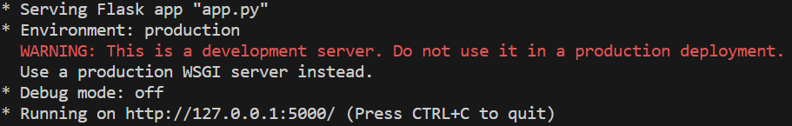

The above screenshot shows the web application is launched successfully, click on the http link, it triggers the browser to open the webpage.

* 1. Conduct operations in the webpage

The functionalities are very straightforward. If there’s any confusion, please refer to the tutorial video.